- Introduction
Nowadays buying gifts online became a very common thing. However, most e-commerce platforms provide fixed products with limited personalization options. Customers often want to create unique and meaningful gifts for special occasions such as birthdays, anniversaries, and festivals. But most of us wants to customize gifts box for our close one.The aim of our project is to develop a website where we can customize a gift box with our favourite products to express our feelings.
From our website customers can select products and personalize them and then can create their own gift boxes.This platform will allow customers to choose items such as chocolates, flowers, cards, and accessories, and combine them into a single customized package.This project is relevant because personalization is becoming a major trend in modern e-commerce. It improves user satisfaction, increases engagement, and improves business opportunities. The system will provide an easy-to-use interface, secure payment options, and efficient order management. This project will demonstrate practical implementation of web development technologies and solve a real-world problem.
- Background Study
Website Name | Objective of the Website
Daraz | General e-commerce platform for buying and selling products online
Amazon | Large-scale online marketplace with diverse product categories
Sugary | Online gift curation and customized gift boxes platform
Ferns N Petals | Online gift delivery service with limited customization
Giftcart | Personalized gift items and occasion-based gift solutions

- Problem Statement
Existing e-commerce platforms have limited choice. Most online shopping websites only offer ready-made products with very limited customization options. As a result, users often have to visit multiple websites to buy different items and create a gift package on their own, which is time-consuming and inconvenient.Many customers want to add a personal touch to their gifts, such as choosing specific items, adding messages, or designing their own gift box. Unfortunately, existing platforms do not provide a simple and flexible way to do this in one place.
This project aims to solve this problem by developing a customized gift box website where users can easily select items, personalize them, and create a complete gift package in a single platform. This will save time, improve user experience, and make gift-giving more thoughtful.
4. Objectives
- To build a simple and user-friendly website where anyone can easily create their own customized gift box without confusion
- To give users the freedom to choose different items and combine them into one meaningful gift package
- To make the shopping process smooth by adding features like login, cart, and secure payment
- To help admins manage products, orders, and users easily from one place.
5. System Design

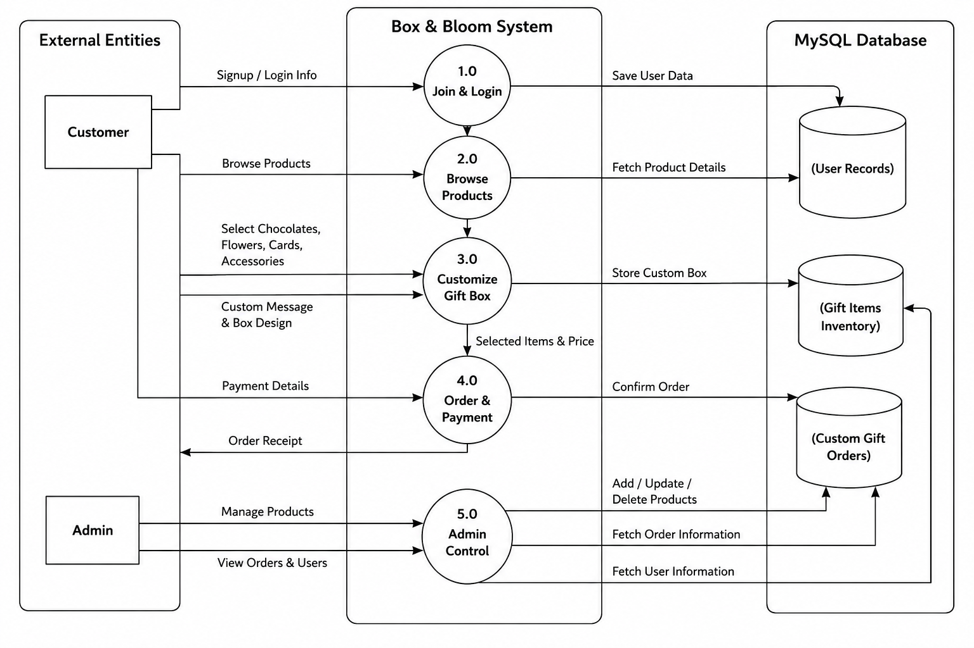
Fig: Data Flow Diagram

6.Expected Outcomes
- Users will be able to easily create and personalize gift boxes based on their preferences, occasions, and budget.
- The website will make online gift shopping more fun, creative, and meaningful instead of just buying ready-made products.
- Small and local businesses in Bangladesh can get more opportunities to sell their products through customized gift boxes.
- Customers will save time because they can select multiple items and design gifts in one place.

7. Tools and Technologies

● Frontend : HTML,CSS, JavaScript, Bootstrap,Figma.

● Backend : PHP , Node.js, REST API .

● Database: MySQL , phpMyAdmin .
● Payment & Email: bKash, Nagad, Rocket Visa/MasterCard ,Email system .

● Tools for Development: Visual Studio Code, XAMPP ,GitHub,Postman.

● Hosting : Localhost (XAMPP).

8. References
- Amazon Official Website (https://www.amazon.com/)
- Daraz Bangladesh (https://www.daraz.com.bd/#?)
- Etsy Platform(https://www.etsy.com/)
- Sugary.com.bd(https://sugary.com.bd/)
- Ferns N Petals(https://www.fnp.com/)

9. Work Division and Team Management
Member | Task
Dipto Sutradhar | Frontend Design
Nafisa Tabassum | Backend Development
Ayesha Nowroz | Database & Testing

10. Timeline
Phase | Activity | Time Duration
Requirement Analysis | Collect requirements, study similar websites, and plan features | Week 1
Design | Create UI/UX design, wireframes, and database structure | Week 2-3
Development | Build frontend, backend, and connect database | Week 4-7
Testing | Test features, fix bugs, and improve system performance | Week 8-9
Final Submission | Final review, documentation, and project submission | Week 10

11.Cost-Benefit Analysis:

Item / Phase | Description | Estimated Cost (BDT) | Benefit
Domain & Hosting | Localhost / basic web hosting setup | 2,000 – 5,000 | Helps run the website online and attract customers
Development Tools | VS Code, XAMPP (mostly free) | 0 – 1,000 | Saves software purchasing cost
UI/UX Design | Figma / Canva design work | 1,000 – 3,000 | Better design may increase customer orders
Frontend Development | HTML, CSS, JavaScript, Bootstrap | 0 (student work) | No hiring cost for frontend developer
Backend Development | PHP + MySQL setup | 0 (student work) | No additional backend development expense
Testing & Debugging | Error fixing and testing | 500 – 1,500 | Reduces future maintenance and fixing costs
Deployment (optional) | Hosting setup for demo | 1,000 – 3,000 | Makes the website available for real users and sales
Profit / Financial Benefit | Income from customized gift box sales | — | Estimated profit can be around 5,000 – 20,000+ BDT per month depending on customer orders and marketing

- Constraints and Limitations
Limited Development Time
Since this is a semester lab project, we have a fixed short deadline. Because of this, we will focus on building the main features like gift box customization, product selection, and basic ordering, rather than adding advanced features like AI recommendations or complex automation.
Basic Security Features Only
We will include simple security measures such as login validation and basic form checks. However, advanced security systems like strong encryption, fraud detection, or enterprise-level protection will not be fully implemented due to time and complexity limitations.
No Full Real Payment System
Although our project is designed to include payment options like bKash or Nagad, we may not be able to integrate real live payment gateways. Instead, we may simulate the payment process for demonstration purposes in the project.
Limited Backend Complexity
The system will mainly focus on core functions like selecting items, customizing gift boxes, and placing orders. Advanced features like real-time inventory tracking or automated delivery management may not be included.
Small Scale Project Scope
This website is designed as a prototype for academic purposes, not a full commercial platform. So, it may not handle large numbers of users or real-world traffic like professional e-commerce websites.

13. Societal Impact
Box & Bloom can make a positive difference in society by helping local small businesses and artisans showcase and sell their products to more people through an online platform. This supports small entrepreneurs in Bangladesh and helps strengthen the growing digital economy.
The platform also encourages more thoughtful and personal gift-giving, which can help improve relationships and emotional well-being by making special occasions more meaningful.
Since the website is simple and mobile-friendly, it makes online shopping easier for people who may not be very familiar with complex international e-commerce sites, supporting digital inclusion.

14.Complex Engineering Problem Mapping

WP1 Depth of Knowledge | WP2 Range of Conflicting Requirements | WP3 Depth of Analysis | WP4 Familiarity of Issues | WP5 Extent of Applicable Codes | WP6 Stakeholder Involvement | WP7 Interdependence
✓ | ✓ | ✓ | ✕ | ✕ | ✕ | ✕
Needs basic to solid knowledge of web development, database, and UI to build the system | Balances customization features with speed, cost, and security. | Needs careful analysis of user needs, order process, and system flow.

Complex Engineering Problem Mapping

EA1 Range of Resources | EA2 Level of Interaction | EA3 Innovation | EA4 Consequences for Society and Environment | EA5 Familiarity
✓ | ✕ | ✓ | ✕ | ✕
Uses tools like programming languages, frameworks, and databases. |  | Adds new idea of personalized gift box customization

16. Green Computing Considerations
Our website is designed with basic green computing ideas to reduce unnecessary resource usage. We will use lightweight web pages (HTML, CSS, JavaScript with Bootstrap) so the site loads faster and uses less data, even on low internet connections in Bangladesh. The system will also use simple and efficient database queries in MySQL to reduce server load. Since the project will mainly run on localhost or basic hosting, it naturally keeps energy usage low compared to large-scale systems. Overall, the focus is on building a simple, fast, and low-resource e-commerce system that is user-friendly and efficient.

17. Lifelong Learning and Personal Development
This project will help us gain practical experience in building a real e-commerce-style system. We will learn how to design and develop a full website, from planning and UI design to backend coding and database management. Working on features like product selection, gift customization, and order handling will improve our problem-solving and coding skills.
It will also help us understand teamwork, project planning, and how real online shopping systems work in practice. Overall, this project will build a strong foundation for our future studies and careers in web development and software engineering.

